Cavile Place Plan for Demolition & Redevelopment

Background
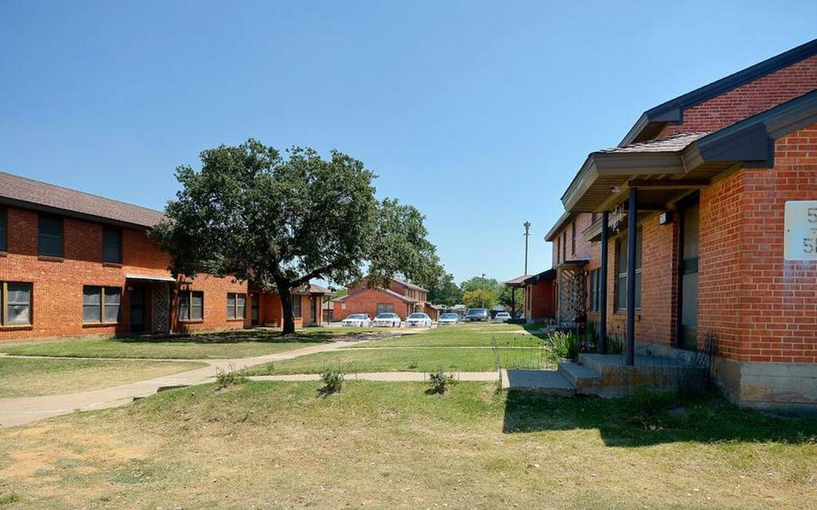
J.A. Cavile Place Apartments is a 300-unit public housing community located in the historic Stop Six neighborhood at 1401 Etta St. Fort Worth, TX 76105.
Built in 1960, the site has capital renovation and repair needs of over $42 million. Without sufficient funding to meet these needs, the conditions at the site will continue to deteriorate over time. Initial analysis has found that the site meets HUD’s threshold for physical obsolescence and would be eligible to submit a Section 18 Inventory Removal Application to HUD for demolition approval.

Plan for Application
Fort Worth Housing Solutions (FWHS) intends to submit a Section 18 Inventory Removal application to HUD’s Special Application Center in 2018. This application, if approved, would allow for the demolition and disposition of the Cavile property to facilitate redevelopment of the site, to include affordable housing. FWHS will continue to meet with residents, resident groups, and the broader community throughout the application process to provide status updates, to answer questions, and to address any concerns.

Plan for Relocation and Demolition
Following approval from HUD, FWHS will seek additional HUD approval for Tenant Protection Vouchers to facilitate relocation for existing residents. These vouchers will serve the same function as typical Section 8 or Housing Choice Vouchers administered by FWHS, and will allow existing residents to find an affordable rental unit within the private market. All eligible residents will also receive permanent relocation counseling and assistance, as prescribed by Section 18 of the U.S. Housing Act of 1937. Once all families have been relocated, FWHS intends to demolish all structures to facilitate redevelopment.

Plans for Redevelopment
FWHS intends to participate in a comprehensive, collaborative and transformative redevelopment process for the Cavile site and the surrounding neighborhood. Throughout this process, FWHS intends to honor the spirit of the 2013 Cavile Place Neighborhood Transformation Plan, which was born out of two years of community engagement and planning. The housing component of any future redevelopment will include units for a mix of incomes and desirable amenities.

